Computer Shop System

Business Use-Case Specification: Shopping Cart

Version 1.0

Revision History

|  |  |  |  |
| --- | --- | --- | --- |
| **Date** | **Version** | **Description** | **Author** |
| 10/12/2019 | 1.0 | details | Pham Thi Hong Trang |
|  |  |  |  |
|  |  |  |  |
|  |  |  |  |

Table of Contents

1. Introduction 4

1.1 Purpose 4

1.2 Scope 4

1.3 Definitions, Acronyms, and Abbreviations 4

1.4 References 4

1.5 Overview 4

2. Business Use-Case Name 4

2.1 Brief Description 4

3. Goals 4

4. Performance Goals 4

4.1 <name of performance goal> 5

5. Workflow 5

5.1 Basic Workflow 5

5.1.1 <name of workflow step> 5

5.2 Alternative Workflows: Still achieve success but in different way 5

5.2.1 <name of workflow step> 5

6. Risk 5

7. Possibilities 5

8. Process Owner 5

9. Special Requirements 5

9.1 <Name of Special Requirement 1> 5

9.2 <Name of Special Requirement 2> 5

10. Extension Points 6

10.1 <Name of Extension Point> 6

Business Use-Case Specification: Shopping Cart

# Introduction

## Purpose

The purposes of this business use-case is to show how the computer shop deals with the situation when customers want to do with shopping cart.

## Scope

The scope of this business use-case is associated with the computer shop to be deployed

## Definitions, Acronyms, and Abbreviations

Manager: admin.

## References

TBD

## Overview

The rest of the Business Use-case Specification contains goal, risk, process owner and special requirement.

# Business Use-Case Name

## Brief Description

The use-case is that “Manage category managers” which means the managers have to deal with all problems related to shopping cart of the online shop.

# Goals

The goal of the business use-case is to help customer doing 3 main activities: add to shopping cart, update shopping cart, view shopping cart.

# Performance Goals

## Customer can add to shopping cart

This perfomance goal is that customer can add a computer which is available in computer hp to shopping cart.

## Customer can view shopping cart

When customer added computer to shopping cart, they can view totally your shopping cart to know about the quantity, color, name or also price.

## Customer can update shopping cart

When customer view shopping cart, they want to change some information about quantity, color... or also delete it getting out shopping cart, they can update shopping cart.

# Workflow

The user adds computer to shopping cart. And then, the user clicks in shopping cart to view all product which customer added. If they want to change about the quantity of product, change about color… they can update t or delete it.

## Basic Workflow

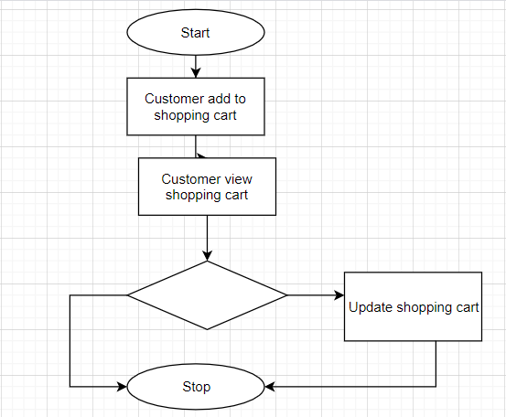

# Risk

No special.

# Possibilities

No special.

# Process Owner

The process owner if this usecase is the administrator or can be called manager of the computer shop who deal with the situation.

# Special Requirements

No special.

# Extension Points

No extension points.